# Digital Spool Holder

## Introduction

A digital spool holder is a device designed to hold and monitor the filament spools used in 3D printing. Unlike a traditional spool holder, which is a passive component, a digital spool holder integrates electronic components to provide additional functionality such as weight measurement and real-time monitoring. This innovative spool holder utilizes an Arduino microcontroller, a load cell, and an OLED display to accurately measure the remaining filament on a spool. In addition, it is user friendly and load cell can be easily calibrated. The main goal of this spool holder is to provide real-time weight data, it enables users to determine if there's sufficient filament for upcoming print jobs making it very useful for minimizing material waste and avoiding failed prints due to insufficient filament. Thus, this spool holder will make our printer more sustainable, efficient and contribute to the following SDGs: Decent Work and Economic Growth (8), Industry Innovation and Infrastructures (9), and Responsible Consumption and production (12).

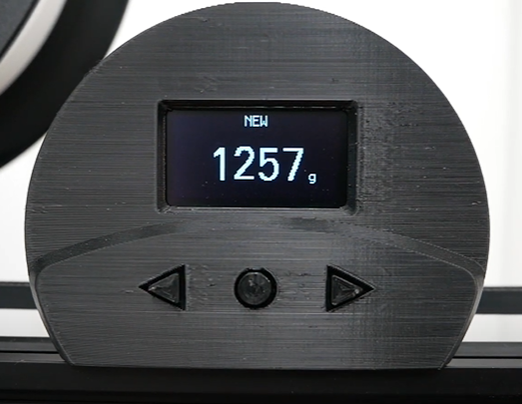

Figure : Digital Spool Holder.

## Equipment

The key equipment used to build this spool holder is:

* Arduino Nano
* Load Cell Weight Sensor HX711
* OLED LCD LED Display 0.96" I2C
* 3 Push Buttons
* 3 10Kohms Resistors
* Breadboard
* Jump wires
* Holding parts printed by a 3D printer
* PCB made in WIRELY way

**Preliminary Research and System Design**

The Wirely Team began with a research phase, during which existing Arduino code samples and circuit diagrams related to digital spool holders were explored. This research provided valuable insights and references that formed the basis of the design. Building on this foundation, the team meticulously designed the circuit diagram for the digital spool holder, ensuring all components and connections were accurately represented, as shown in the following figure.

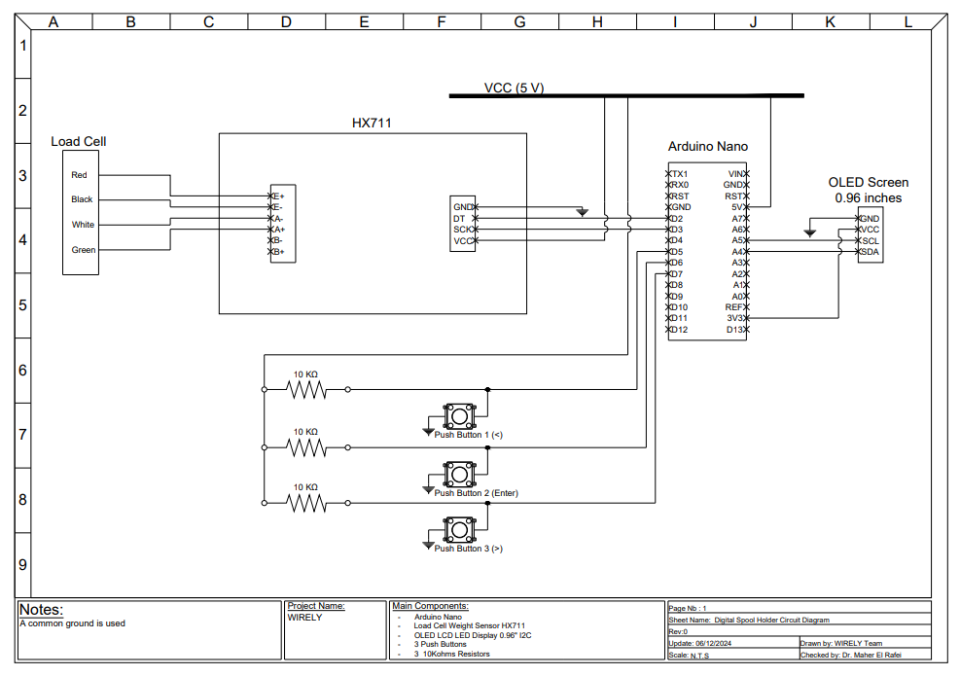

Figure : Circuit Diagram of the Digital Spool Holder.

As we can see in the previous figure, each push button has a specific role: “going left”, “enter” and “going right”; which in the calibration, in the options and other features of the digital spool holder. Then, the team created a detailed 2D block diagram to visually map out the system’s architecture and functionality, as shown in the following figure.

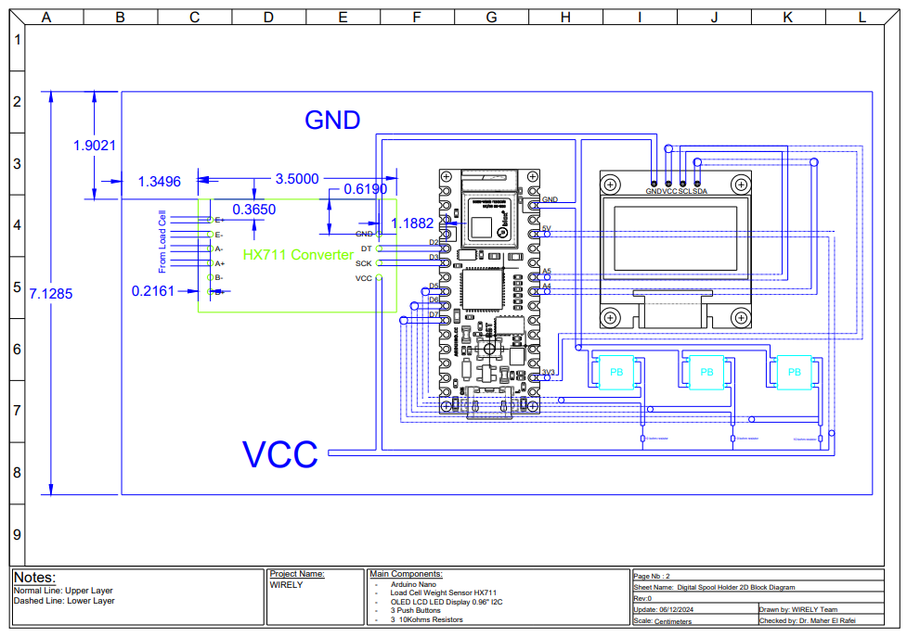

Figure 3: 2D Block Diagram of the Digital Spool Holder.

With these preparatory steps completed, the team was ready to proceed confidently to the implementation and testing phase, ensuring a streamlined and efficient workflow.

## Implementation

The team began by assembling the circuit on a breadboard, allowing for easy adjustments and modifications during the initial testing phase. They uploaded and tested the Arduino code, ensuring proper communication and functionality of the components. A sample test was conducted to evaluate the system’s performance, during which the team successfully demonstrated the trial run of the digital spool holder.

However, some challenges were encountered during the process, including soldering difficulties and the precise calibration of the load cell. To address these issues, the team visited the manufacturing lab, where they worked on securely fixing the load cell to a custom mount. This adjustment was critical for stabilizing the load cell and ensuring accurate weight measurements, enabling the system to perform reliably in the intended application, as shown in the figure below.

(ADD PICTURE OF THE CIRCUIT)

After the successful testing phase, the team advanced to designing the 3D model of the digital spool holder circuit’s PCB and its holder components using SolidWorks. The holder designs were then built using a 3D printer in the lab, ensuring precision and functionality in the final physical structure. Additionally, the team printed the PCB using the Wirely method, which stood out for its exceptional neatness, organization, and professional quality compared to the circuit on a breadboard as shown in the following figure.

(ADD A PICTURE OF PCB)

This comprehensive approach not only showcased the team's technical expertise but also highlighted the clear advantages of Wirely's applications, reflecting their commitment to delivering well-structured and efficient solutions.

## Load Calibration Steps

In order for the digital spool holder to work, calibrating the load cell is essential. However, in our model, the calibration is clear and straight forward which makes our model user friendly. So to calibrate the load cell, the following steps needs to be followed:

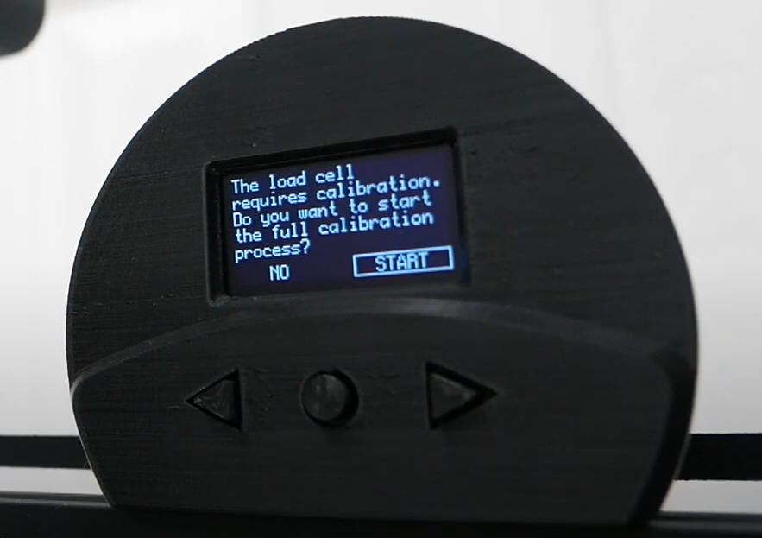

Figure : Load Cell Calibration Step 1.

**Step 1:** As shown in the previous figure, the arrow to the left represent the “Push Button 1” of the circuit diagram and has a function of going left, the middle button represent the “Push Button 2” of the circuit diagram and has a function of “enter”, and the arrow to the right represent the “Push Button 3” of the circuit diagram and has a function of going right. After plugging the arduino nano, this message will pop on the screen, so the user need to go to “Start” using the arrows and press the middle button.

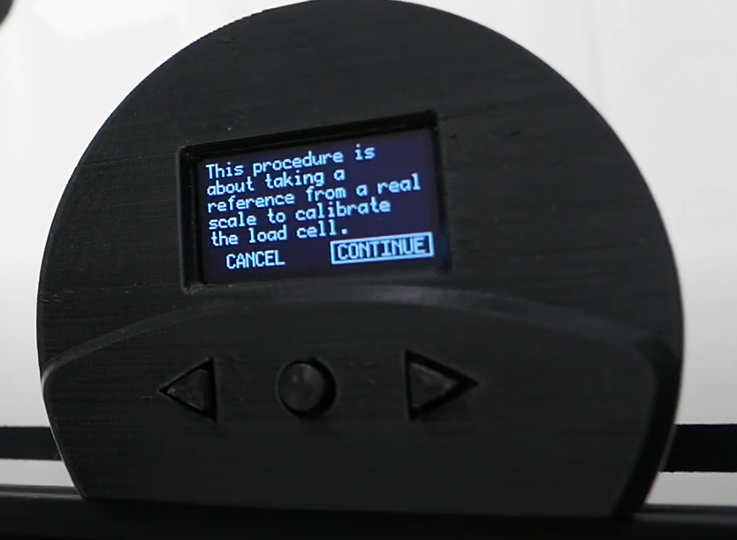

Figure : Load Cell Calibration Step 2

**Step 2:** This message will pop on the screen after step 1, so the user need to go to “Continue” using the arrows and press the middle button.

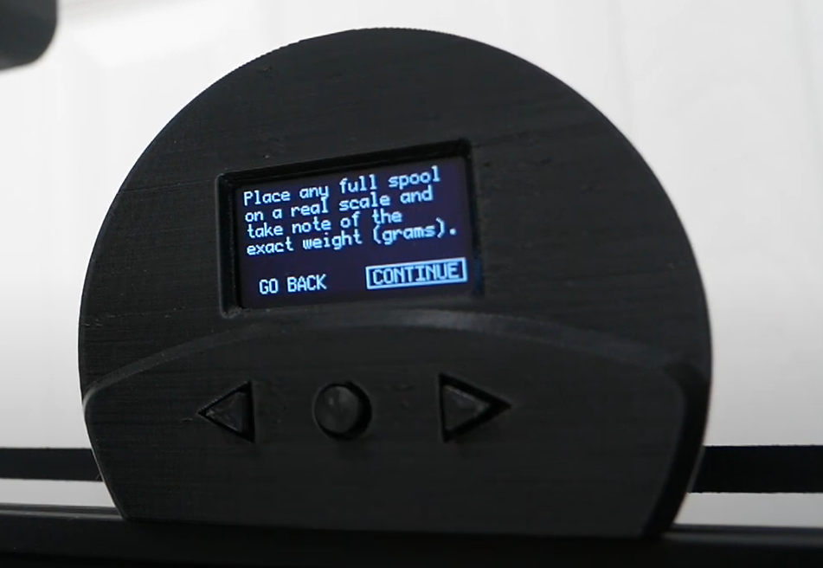

Figure : Load Cell Calibration Step 3

**Step 3:** This message will pop on the screen after step 2, and as mentioned the user needs to measure the full spool of filament on a real scale and take note of the exact weight in grams, then go to “Continue” using the arrows and press the middle button.

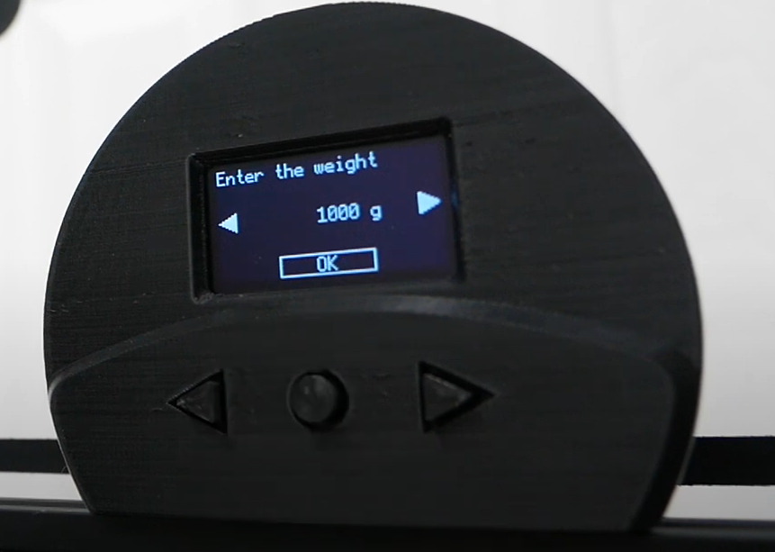

Figure : Load Cell Calibration Step 4.

**Step 4:** This message will pop on the screen after step 3, and as mentioned the user need to enter the measure weight of the full spool of filament in grams. The user can change the weight using the right arrow to make it heavier and left arrow to make in lighter, then press “Ok” using the middle button.

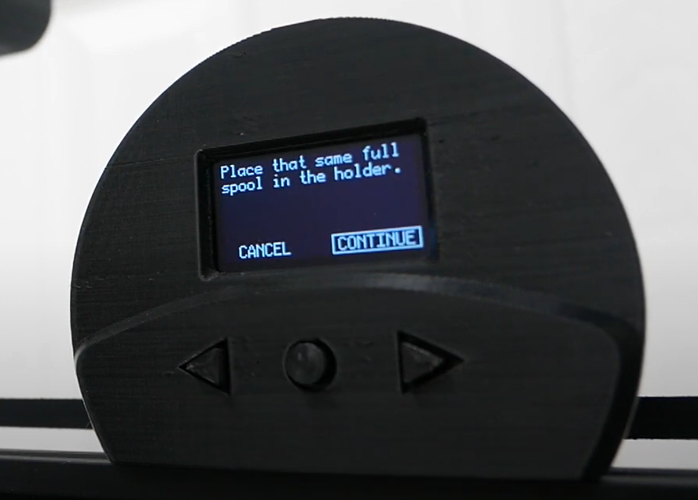

Figure : Load Cell Calibration Step 5.

**Step 5:** This message will pop on the screen after step 4, and as mentioned the user needs to put the full spool of filament in the holder and then go to “Continue” using the arrows and press the middle button.

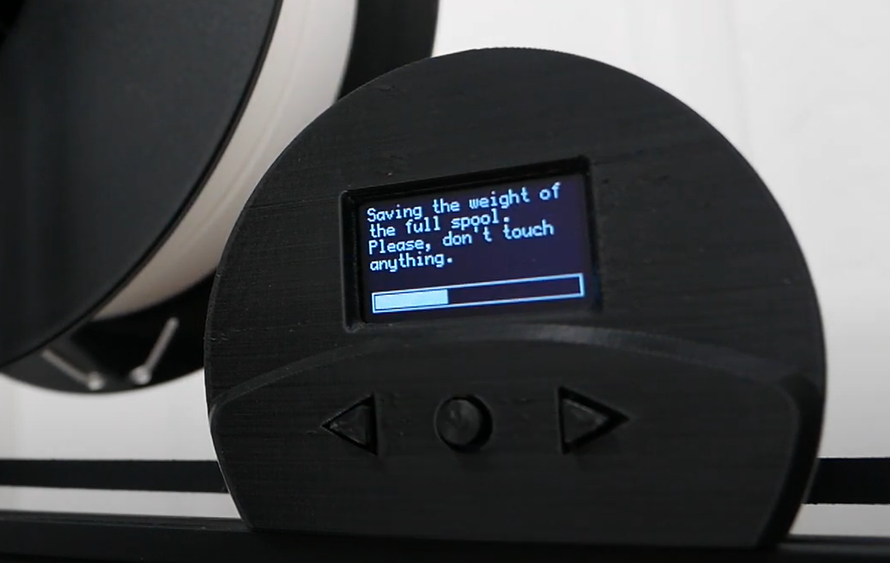

Figure : Load Cell Calibration Step 6

**Step 6:** This message will pop on the screen after step 5, showing that the system is saving the weight of the full spool. However, the user is restricted not to touch anything in order to have precise weight values.

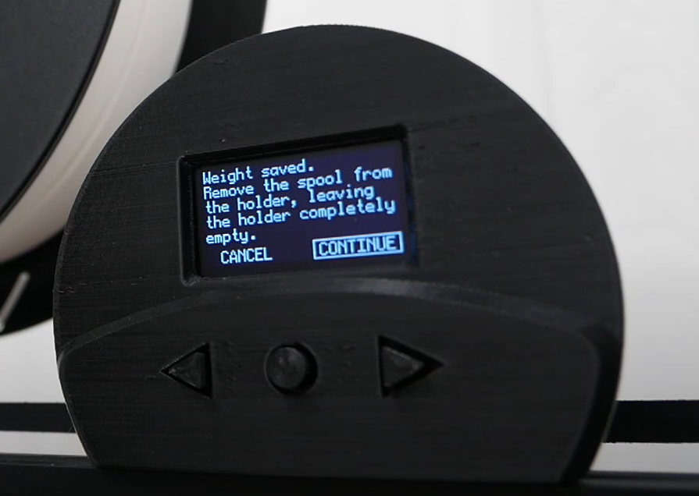

Figure : Load Cell Calibration Step 7

**Step 7:** This message will pop on the screen after step 6, showing that the system saved the weight of the full spool. Now, the user needs to remove the full spool from the holder, and here two options are available based on the need:

Option 1: if the user wants “the weight of the spool + the filament” to show, then he needs to leave the spool completely empty and go to “Continue” using the arrows and press the middle button.

Option 2: if the user wants “the weight of the filament available” to show, then he needs to put an empty spool on the holder and go to “Continue” using the arrows and press the middle button.

In other words, in this step, the user is setting the reference point.

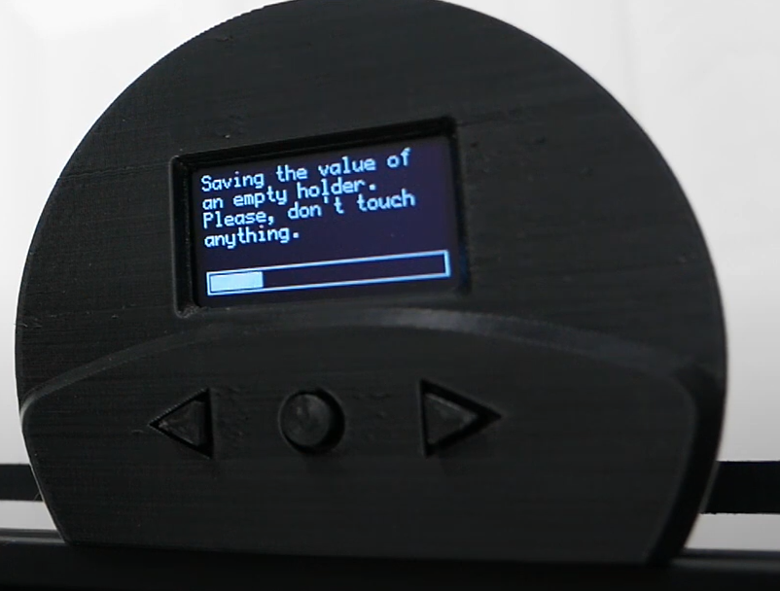

Figure : Load Cell Calibration Step 8

**Step 8:** This message will pop on the screen after step 7, showing that the system is saving the reference weight. However, the user is restricted not to touch anything in order to have precise weight values

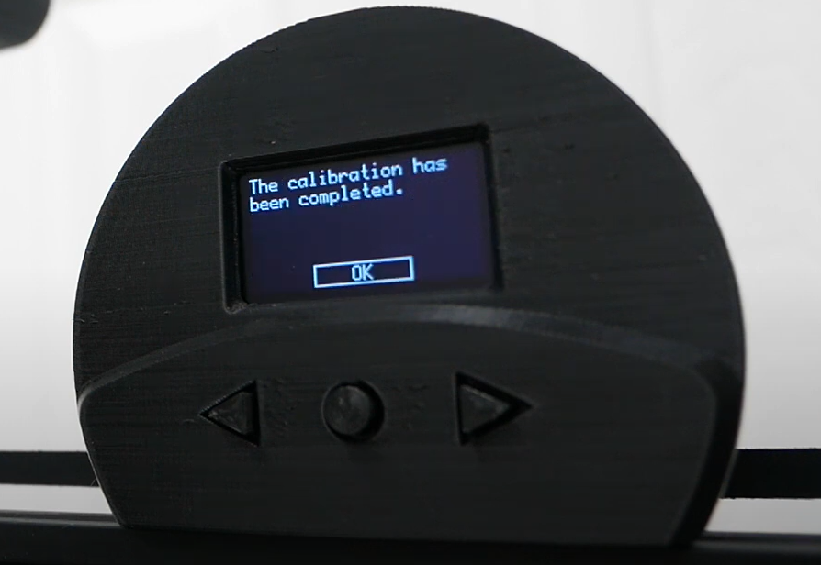

Figure : Load Cell Calibration Step 9

**Step 9:** This message will pop on the screen after step 8, showing that the calibration has been completed. However, the user needs to press “OK” using the middle button.

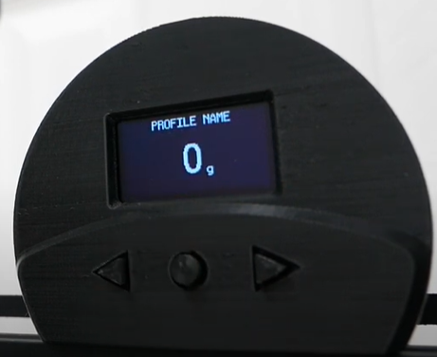

Figure : Load Cell Calibration Step 10.

**Step 10:** This message will pop on the screen after step 9, showing the weight on the spool holder. Note that in this case the spool holder is empty that why it is showing 0g.

In addition, other features are included in this application located in the main menu such as editing the profile, adding a new profile (Repeat all the calibration steps mentioned above for another spool type) and options (as shown in the figure below). The main menu is entered by pressing the middle button.

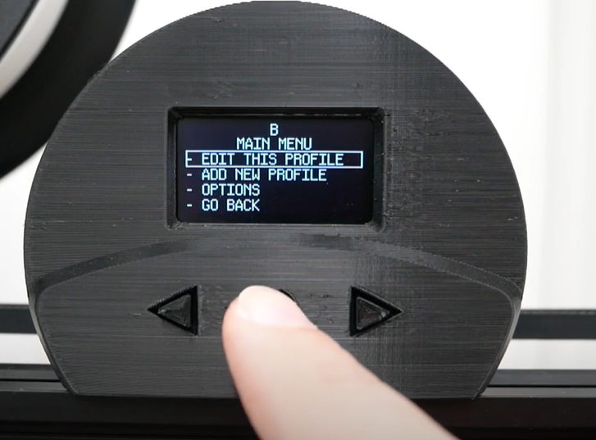

Figure : Digital Spool Holder “Main Menu” tab

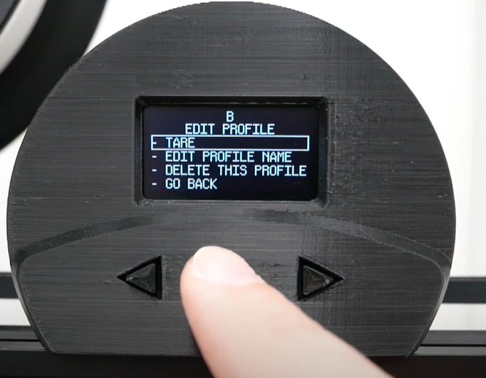

Figure : Digital spool holder “Edit Profile” tab

As shown in the figure above, in the “Edit Profile” tab, the user can change the reference point in “Tare”, change the profile name in “Edit Profile Name”, delete the profile in “delete this profile” or go back by pressing on “Go Back”

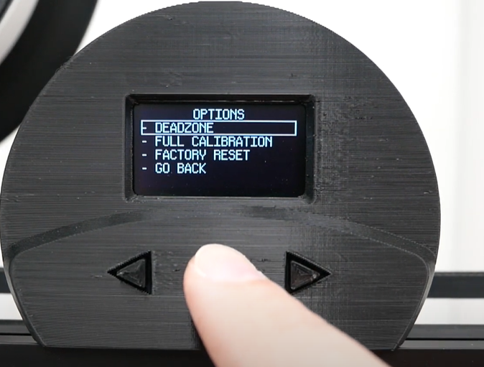

Figure : Digital spool holder "Options" tab

As shown in the figure above, in the “Option” tab, the user can add a deadzone in “Deadzone”, do a full calibration in “Full Calibration”, reset all the saved settings in “Factory Reset” or go back by pressing on “Go Back”.

# References

* InterlinkKnight. (n.d.). Digital Spool Holder (with Scale): 5 Steps (with Pictures). Instructables. Retrieved December 7, 2024, from <https://www.instructables.com/Digital-Spool-Holder-with-Scale/>
* MakerTales. (2023, January 10). *Digital Spool Holder (with Scale)* [Video]. YouTube. <https://www.youtube.com/watch?v=WO-hR7okl3k>